**Experiment No. 10**

PART A

(PART A: TO BE REFFERED BY STUDENTS)

**A.1 Aim:**

Final Development

**A.2 Prerequisite:**

Core java programming and basic knowledge of database

**A.3 Outcome:**

**After successful completion of this experiment students will be able to**

1. Have the fully working application.

**A.4. Procedure:**

**Tasks:**

a) Testing the entire app for its correctness

c) Save the document as **EXP10_ your Roll no.**

PART B

(PART B: TO BE COMPLETED BY STUDENTS)

**(Students must submit the soft copy as per following segments within two hours of the practical. The soft copy must be uploaded on the Blackboard or emailed to the concerned lab in charge faculties at the end of the practical in case the there is no Black board access available)**

|  |  |
| --- | --- |
| Roll No. B046 | Name: Pranav Joshi |
| Program: B.tech Computer | Division: B |
| Semester: IV | Batch : B3 |
| Date of Experiment: 9-4-15 | Date of Submission: 16-4-15 |
| Grade : |  |

B.1 Task to be done:

**1)** Paste Source code of .xml and .java files in this section along with output.

package com.drunktest;

public final class BuildConfig {

public final static boolean DEBUG = true;

}

public static String [] questionsArray = new String[6];

public static String [][] answerOptionsArray = new String[6][4];

public static int queCount=0;

public static int [] answers = new int[6];

@Override

public void onCreate() {

// TODO Auto-generated method stub

super.onCreate();

questionsArray[0] = " Difference between no of matchsticks?";

questionsArray[1] = " How many triangles?";

questionsArray[2] = " How many differences?";

questionsArray[3] = " How many numbers can you see?";

questionsArray[4] = " Which line is longer?";

questionsArray[5] = " How many pairs of eyes and noses do you see?";

answers[0] = 4;

answers[1] = 3;

answers[2] = 2;

answers[3] = 2;

answers[4] = 3;

answers[5] = 2;

answerOptionsArray[0][0] = "a) 2";

answerOptionsArray[0][1] = "b) 1";

answerOptionsArray[0][2] = "c) -2";

answerOptionsArray[0][3] = "d) a & c";

answerOptionsArray[1][0] = "a) 24";

answerOptionsArray[1][1] = "b) 25";

answerOptionsArray[1][2] = "c) 26";

answerOptionsArray[1][3] = "d) 17";

answerOptionsArray[2][0] = "a) 13";

answerOptionsArray[2][1] = "b) 15";

answerOptionsArray[2][2] = "c) 12";

answerOptionsArray[2][3] = "d) 17";

answerOptionsArray[3][0] = "a) 3";

answerOptionsArray[3][1] = "b) 0";

answerOptionsArray[3][2] = "c) 4";

answerOptionsArray[3][3] = "d) 2";

answerOptionsArray[4][0] = "a) A";

answerOptionsArray[4][1] = "b) B";

answerOptionsArray[4][2] = "c) Both are equal";

answerOptionsArray[4][3] = "d) Wrong question";

answerOptionsArray[5][0] = "a) 1 & 2";

answerOptionsArray[5][1] = "b) 2 & 0";

answerOptionsArray[5][2] = "c) 4 & 2";

answerOptionsArray[5][3] = "d) Wrong question";

}

}

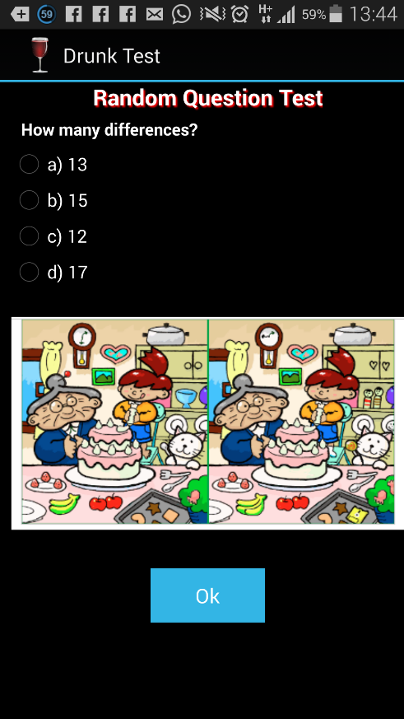 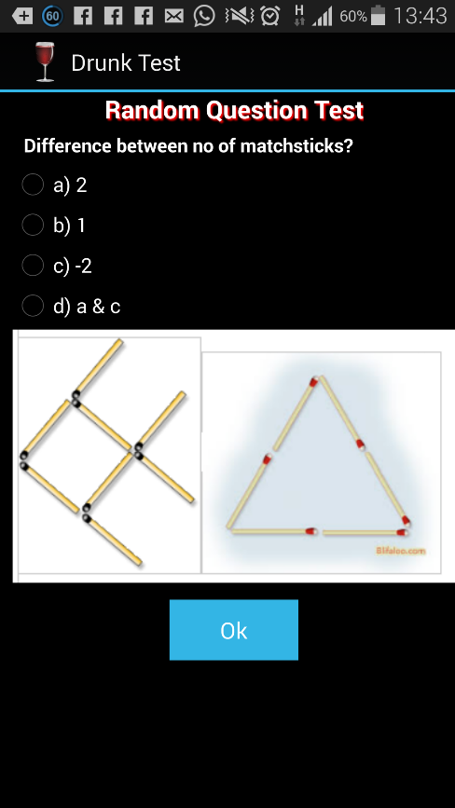

B.3 Conclusion:

The app was tested in its entirety. No errors were reported. Hence the application development was successful.